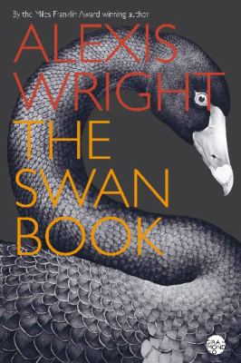
The Swan Book by Alexis Wright

Synopsis
The Swan Book is set in the future, with Aboriginal peoples still living under the Intervention in the north, in an environment fundamentally altered by climate change. It follows the life of a mute young woman called Oblivia, the victim of gang-rape by petrol-sniffing youths, from the displaced community where she lives in a hulk, in a swamp filled with rusting boats, and thousands of black swans, to her marriage to Warren Finch, the first Aboriginal president of Australia, and her elevation to the position of First Lady, confined to a tower in a flooded and lawless southern city.
The Swan Book offers an intimate awareness of the realities facing Aboriginal people; the energy and humour in her writing finds hope in the bleakest situations; and the remarkable combination of storytelling elements, drawn from myth and legend and fairy tale, has Oblivia Ethylene in the company of amazing characters like Aunty Bella Donna of the Champions, the Harbour Master, Big Red and the Mechanic, a talking monkey called Rigoletto, three genies with doctorates, and throughout, the guiding presence of swans.

Discussion questions
- Alexis Wright’s new novel is called The Swan Book, and clearly swans – black swans mainly, but white swans also – play an important role in it. What is their significance?
- There are other animals featured in the novel, including brolgas, owls, miner birds, rats, dogs and even a monkey, called Rigoletto – what use does Wright make of these and other animals?
- Wright has taken a young woman recovering from trauma, who is unable or unwilling to speak, as the hero of her novel. How crucial is the sense of injury and helplessness to your understanding of the book?
- The issue of Aboriginal sovereignty is central to The Swan Book – in what ways is it developed, and to what conclusions?
- How important is the theme of climate change in the novel, and what are some of its social implications? What other issues arise from Wright’s setting the novel in the future?
- Wright’s novels always have colourful characters – here they include Lady Bella Donna of the Champions, the Harbour Master, Big Red, Mechanic and the three Genies. What do you make of these characters, and particularly Warren Finch, the first Aboriginal President of Australia?
- Critics have often commented on the richness and energy of Wright’s style of writing, its orchestration of voices, and its expressive power, to the point of bending grammar and syntax. How do you respond to this style, as a reader?
- What role do fairy-tales play in The Swan Book and how does the incorporation of these different literary traditions effect the scope of the novel?
Discussion questions from https://giramondopublishing.com/books/the-swan-book/

