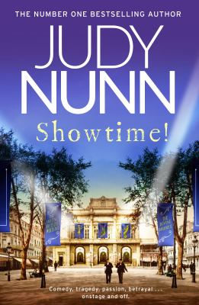
Showtime! By Judy Nunn

Synopsis
In the second half of the 19th century, Melbourne is a veritable boom town, as hopefuls from every corner of the globe flock to the gold fields of Victoria.
And where people crave gold, they also crave entertainment.
Enter stage right: brothers Will and Max Worthing and their wives Mabel and Gertie. The family arrives from England in the 1880s with little else but the masterful talents that will see them rise from simple travelling performers to sophisticated entrepreneurs.
Enter stage left: their rivals, Carlo and Rube. Childhood friends since meeting in a London orphanage, the two men have literally fought their way to the top and are now producers of the bawdy but hugely popular ‘Big Show Bonanza’. The fight for supremacy begins.
Waiting in the wings: Comedy, tragedy, passion and betrayal; economic depression, the Black Death and the horrors of World War One…

Discussion questions
- Like the tragi-comedy masks, the characters in Showtime! often operate as opposing pairs. What draws these characters together?
- ‘Showbusiness people judge, and were judged, according to talent, not colour, not race.’ In what ways does the theatre act as a leveller in the story? What unique journeys have characters like Irving Sayles taken to get to centre stage? What obstacles have they overcome?
- Gilda comes up with a number of reasons why Rosie wants to destroy Carlo. Which do you think come closest to the truth? And what do you think of Gilda’s decision to ‘save Rosie from herself’?.
- Shakespeare’s tragedies of doomed love, thwarted ambition, jealousy and revenge feature throughout the story, particularly Romeo and Juliet. In what ways does life imitate art in the novel?
- At the end of the book, both Will and Carlo think Alfie is ‘the greatest performer of them all’. Why do they feel this way?
- Judy’s successful acting career gives us an all-access pass into the world of the theatre. How does the theatre evolve through the course of the novel? What behind-the-scenes details and innovations did you enjoy the most?
- How is celebrity explored in the novel? What elements of celebrity were unique to the setting of Showtime! and how is modern celebrity different? In what ways is it the same?
- The theatre is a place where the outside world recedes and people lose themselves in the storytelling. How is this unique relationship between the audience and actors explored in the novel? What was the most memorable time you’ve had in the theatre?
Discussion questions from https://www.penguin.com.au/book-clubs/3174-showtime-book-club-notes

